 REPORT ON
INTERNSHIP 2024-25
Carried out on

Event Management Website
Submitted to

NMAM INSTITUTE OF TECHNOLOGY, NITTE
(Off-Campus Centre, Nitte Deemed to be University, Nitte - 574 110, Karnataka, India)

In partial fulfillment of the requirements for the award of the

Degree of Bachelor of Technology in
Computer Science and Engineering
By

{Enter name}
USN: {enter usn}

Under the guidance of

Dr. Ashwin Shenoy
Professor, Department of Computer Science and Engineering

CERTIFICATE

This is to certify that the “Internship report” submitted by Mr. {name} bearing USN: {NNM24CS---} of Second year B.Tech., a Bonafide student of NMAM Institute of Technology, Nitte, has undergone internship on building a “Event Management Website” during the year 2024-25 fulfilling the partial requirements for the award of degree of Bachelor of Technology in Computer Science and Engineering at NMAM Institute of Technology, Nitte.

Signature of the professor Signature of H.O.D (Computer Science)

ACKNOWLEDGEMENT

The internship opportunity to develop the “Event Management Website” provided an excellent platform for learning and professional growth. I am deeply grateful to all those who guided and supported me through this project.
We dedicate this page to acknowledging and thanking those responsible for shaping the project. Without their guidance and help, the experience during the internship would not have been so smooth and efficient.
We are incredibly thankful to our principal, Dr. Niranjan N. Chiplunkar, for their support and encouragement.
We owe our profound gratitude to Dr. Jyothi Shetty, the head of the department of Computer Science and Engineering. Their kind consent and guidance helped us to complete this work successfully.
We sincerely thank Dr. Ashwin Shenoy, our professor and mentor, from the Department of Computer Science and Engineering for her guidance and valuable suggestions which helped us to complete the project.
We also thank our friends and family members for their continuous support.

I would also like to thank NMAM Institute of Technology for providing me the opportunity to choose a subject of interest for our internship project and equipping us with the necessary resources to complete it successfully.

INDEX
Acknowledgement………………………………………………………………………3
Abstract…………………………………………………………………………………..5
- Introduction
  - Details of the mini project…………………………………………..…..6
  - Objectives ………………………………………………………………7
  - Scope & Importance…………………………………………………………………………...8
  - Technology used………………………………………………………………………9
- Result………………………………………………………………………………...10
- Conclusion…………………………………………………………………………….12
- Reference…………………………………………………………………………….13

Abstract

This project aimed to design and build an Event Management Website using HTML, CSS, and JavaScript. The goal was to create a front-end application that makes it easy to create events, list them, schedule them, set reminders, and manage basic user login. Key features included a responsive landing page, an event catalog, secure sign-up and login forms, and an event scheduler with countdown timers and automated email reminders, which were set up using EmailJS.

The focus was on responsive design, accessibility, and form validation to make sure everything worked well on different devices. We used Browser Local Storage to keep user-specific data during this phase of the project. We faced challenges like adding a dynamic search, synchronizing countdowns, and ensuring reliable client-side notifications. We solved these issues with iterative JavaScript solutions and thoughtful UI/UX choices.

This project showcases hands-on front-end development skills by building a fully functional event scheduler with real-time countdowns and reminders. It also sets the stage for future enhancements, like adding a backend, enabling shared events.

1.Introduction

Details of the mini project:
For our mini project, we built a web-based Event Countdown Timer with Reminder to help users easily schedule and keep track of their personal events. The goal was to make it simple and intuitive—whether someone is on a phone, tablet, or laptop, they can quickly add events and see how much time is left until each one.

The app includes features like a responsive event scheduler, a form to add events with date and time, live countdown timers, and automatic reminders through alerts and emails. Everything is designed to be clean and straightforward so users can stay organized without any confusion.

We developed the platform using HTML, CSS, and JavaScript, combining structure,

style, and interactivity to create a fully functional tool.

This project gave us practical experience with user authentication, local storage, real-time countdowns, and email notifications, boosting our confidence in building more complex applications. It shows that even a simple front-end tool can make managing personal events easier and more effective.

1.2 Objectives

Make it easy for users to add, view, and manage their personal events..

Show real-time countdowns so users can see how much time is left for each event..

Give reminders through alerts and emails so important event aren’t missed.

Keep user data and events securely stored in the browser, with personal sessions for each user.

Ensure the app looks and works great on any device, whether it’s a phone, tablet, or laptop.

1.3 Scope & Importance

The Event Countdown Timer with Reminder is a dynamic web-based tool designed to help users manage their personal events efficiently. With a user-friendly interface, it provides essential features like event scheduling, countdown tracking, and reminders, ensuring users stay organized and never miss an important event.

Event Management Made Simple:
Users can quickly add new events with a title, date, and time, view upcoming events in a clean list, and delete events they no longer need. The platform focuses on simplicity and ease of use.

Interactive Reminders:
The application provides real-time countdowns for each event and sends alerts 10 minutes before an event starts. Email notifications are also sent using EmailJS, helping users stay on top of their schedule.

Personalized User Sessions:
Each user has their own account, and events are saved per user in the browser’s local storage. This ensures personalized access to schedules without mixing data between users.

Responsive Design:
The application is designed to work smoothly on desktops, tablets, and mobile devices, providing a consistent and accessible experience across different screen sizes.

Practical Learning and Real-World Use:
While the project is a mini project, it demonstrates practical front-end development skills, combining HTML, CSS, and JavaScript to solve a real personal productivity problem.

1.4 Technology Used

HTML: Used to structure the web pages, including the login/signup forms and the event dashboard, providing semantic sections for better organization and accessibility

CSS: Applied for styling and layout, ensuring the interface is visually appealing and responsive. Media queries and flexbox were used to make the app look consistent across desktops, tablets, and mobile devices.

JavaScript: Powered the interactive features, including user authentication, adding and deleting events, real-time countdown timers, dynamic search and filters, and sending email reminders via EmailJS.

EmailJS: Integrated to send automated reminder emails 10 minutes before an event starts, demonstrating client-side notification functionality.

Browser Local Storage: Used to save user accounts and events on the client-side, providing a simple way to persist user data without a backend.

2.RESULT

The Event Countdown Timer with Reminder successfully delivers a functional and user-friendly web application that allows users to schedule, track, and manage their personal events. Below are examples of the key pages, showcasing the implemented features and design:

Login Page:
Users can securely log in using their registered email and password. The interface is clean, simple, and responsive, providing a smooth start to the application.

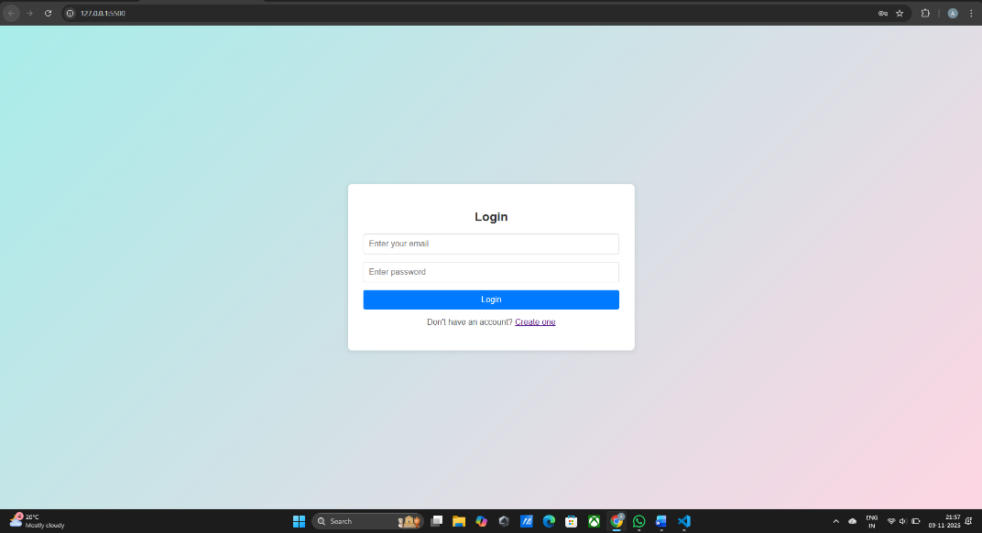

[Fig 1.Login page]

- Signup Page:
New users can create an account by entering their name, email, and password. Input validation ensures secure and accurate registration, while the layout remains intuitive and easy to use.

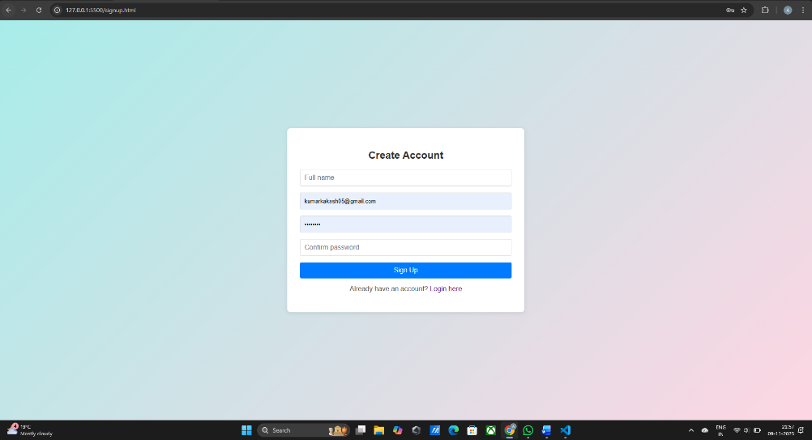

[Fig 2.Sign up page]

Event Scheduler Page:
After logging in, users can add new events, view a list of upcoming events, see real-time countdowns, receive alerts, and get email reminders. The page provides a straightforward interface for managing personal schedules effectively.

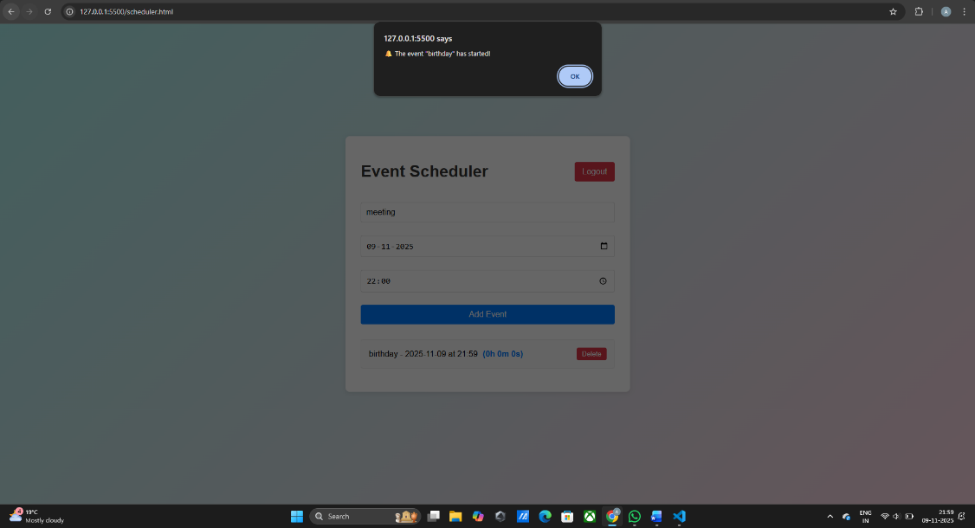

[Fig 3.Event Scheduler Page]

3.CONCLUSION

The Event Countdown Timer with Reminder provides a functional and user-friendly front-end solution for managing personal events. This project reinforced my foundational skills in HTML, CSS, and JavaScript, while addressing practical challenges such as responsive design, form validation, real-time countdowns, and client-side reminders..

The current implementation uses Local Storage to persist user-specific events and demonstrates email notifications through EmailJS. The structure of the project also allows for future enhancements, such as backend integration for persistent user accounts, shared events, and server-side notifications.

Overall, this project improved my hands-on development skills, taught me how to balance usability with technical constraints, and prepared me to build more complex and interactive web applications in the future.

4.REFERENCE

- ·GeeksforGeeks – HTML Tutorial.
https://www.geeksforgeeks.org/html-tutorial/
- GeeksforGeeks – CSS Tutorial.
https://www.geeksforgeeks.org/css-tutorial/
- W3Schools – JavaScript Reference
https://www.w3schools.com/js/
- EmailJS Documentation – Client-side email service.
https://www.emailjs.com/docs/
- MDN Web Docs – HTML & CSS References
https://developer.mozilla.org/

